|  |  |
| --- | --- |
| **Test Case Number** | **Testing** |
| 1 | Online/Offline Handling |
| 2 | Basic Navigation |
| 3 | Orientation Handling |
| 4 | Date Refinement |
| 5 | Data Filter |
| 6 | Unfiltering |
| 7 | Other Device Testing |

|  |  |
| --- | --- |
| **1.1** | **PASS** |
| **1.2** | **PASS** |
| **1.3** | **PASS** |
| **2.1** | **PASS** |
| **2.2** | **PASS** |
| **2.3** | **PASS** |
| **2.4** | **PASS** |
| **2.5** | **PASS** |
| **2.6** | **PASS** |
| **2.7** | **PASS** |
| **3.1** | **PASS** |
| **3.2** | **PASS** |
| **3.3** | **PASS** |
| **4.1** | **PASS** |
| **4.2** | **PASS** |
| **4.3** | **PASS** |
| **4.4** | **PASS** |
| **4.5** | **PASS** |
| **5.1** | **PASS** |
| **5.2** | **PASS** |
| **5.3** | **PASS** |
| **5.4** | **PASS** |
| **5.5** | **PASS** |
| **5.6** | **PASS** |
| **5.7** | **PASS** |
| **5.8** | **PASS** |
| **5.9** | **PASS** |
| **6.1** | **PASS** |
| **6.2** | **PASS** |
| **7.1** | **PASS** |

|  |  |  |  |  |  |
| --- | --- | --- | --- | --- | --- |
| **Test Data** | | | | | |
| **Test Case** | **Input Data** | **Expected output** | **Actual Output** | **Pass/Fail** | **Evidence** |
| **1 – Online/Offline Handling** | | | | | |
| 1.1 | Load application on airplane mode | Application displays Toast message to say connection cannot be established | Application displays Toast message to say connection cannot be established | Pass | Test Figure 1 |
| 1.2 | Turn airplane mode off while application is on and had not loaded | Application loads list of earthquakes automatically | Application loads list of earthquakes automatically | Pass | Test Figure 2 |
| 1.3 | Turn airplane mode on while application is on | Earthquakes loaded remain, toast message displays | Earthquakes loaded remain, toast message displays | Pass | Test Figure 3 |
| **2 – Basic Navigation** | | | | | |
| 2.1 | Scroll List | Scrolls without issue | Scrolls without issue | Pass |  |
| 2.2 | List/Map Switch | Switches to map view | Switches to map view | Pass | Test Figure 4 |
| 2.3 | Spinner | Drop Down List drops | Drop Down List drops | Pass | Test Figure 5 |
| 2.4 | Datepicker | Datepicker shows | Datepicker shows | Pass | Test Figure 6 |
| 2.5 | Click earthquake on list | Earthquake View Shows for specific earthquake | Earthquake View Shows for specific earthquake | Pass | Test Figure 7 |
| 2.6 | Click earthquake on map | Marker box opens | Marker box opens | Pass | Test Figure 8 |
| 2.7 | Click marker box | Earthquake View Shows for specific earthquake | Earthquake View Shows for specific earthquake | Pass |  |
| **3 – Orientation Handling** | | | | | |
| 3.1 | Scroll list horizontal | Scroll list displays | Scroll list displays | Pass | Test Figure 9 |
| 3.2 | Map view horizontal | Map view displays | Map view displays | Pass | Test Figure 10 |
| 3.3 | Earthquake view horizonal | Earthquake view displays | Earthquake view displays | Pass | Test Figure 11 |
| **4 – Date Refinement** | | | | | |
| 4.1 | 1/4/19 chosen as date | No earthquakes to display message displayed | No earthquakes to display message displayed | Pass | Test Figure 12 |
| 4.2 | 3/3/19 chosen as date | Earthquake on the 3/3 displays | Earthquake on the 3/3 displays | Pass | Figure 13 |
| 4.3 | Cancel chosen on date screen | Clears date refinement | Clears date refinement | Pass |  |
| 4.4 | 8/3/19 chosen on date screen while “English Earthquakes” filter is chosen | Only shows English earthquakes with chosen date | Only shows English earthquakes with chosen date | Pass | Figure 14 |
| 4.5 | 20/3/20 chosen as date | No earthquakes to display message displayed | No earthquakes to display message displayed | Pass |  |
| **5 – Data Filter** | | | | | |
| 5.1 | Largest Magnitude chosen | Largest Magnitude earthquake displayed | Largest Magnitude earthquake displayed | Pass | Figure 15 |
| 5.2 | Smallest Magnitude chosen | Smallest Magnitude displayed | Smallest Magnitude displayed | Pass | Figure 16 |
| 5.3 | Most northern chosen | Most northern displayed | Most northern displayed | Pass | Figure 17 |
| 5.4 | Most southern chosen | Most southern displayed | Most southern displayed | Pass | Figure 18 |
| 5.5 | Most eastern chosen | Most eastern displayed | Most eastern displayed | Pass | Figure 19 |
| 5.6 | Most western chosen | Most western displayed | Most western displayed | Pass | Figure 20 |
| 5.7 | Scottish Earthquakes chosen | Only Scottish earthquakes displayed | Only Scottish earthquakes displayed | Pass | Figure 21 |
| 5.8 | English Earthquakes Chosen | English Earthquakes displayed | English Earthquakes displayed | Pass | Figure 22 |
| 5.9 | Welsh Earthquakes Chosen | Welsh Earthquakes displayed | Welsh Earthquakes displayed | Pass | Figure 23 |
| **6 - Unfiltering** | | | | | |
| 6.1 | All earthquakes chosen | All earthquakes displayed | All earthquakes displayed | Pass | Figure 24 |
| 6.2 | Scottish earthquakes chosen on map view and view changed to list | Scottish earthquakes are still the only earthquakes displayed | Scottish earthquakes are still the only earthquakes displayed | Pass | Figure 25 |
| **7 - Other Device Testing** | | | | | |
| 7.1 | Test on Google Pixel 2 XL | Works appropriately | Works appropriately | Pass | Figures 26 |

Figure 1:

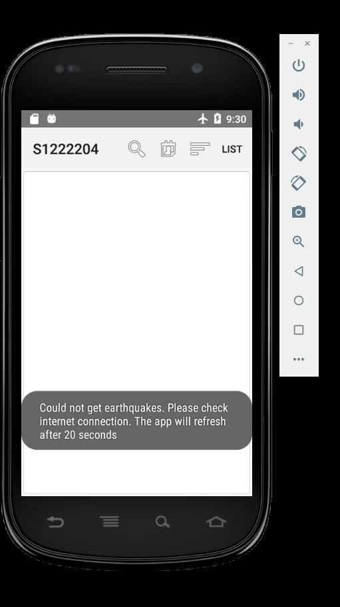

Figure 2:

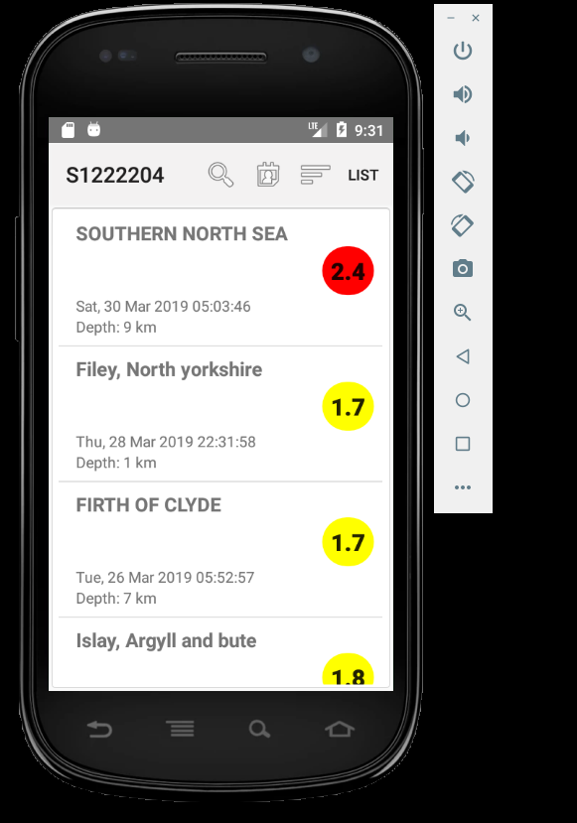

Figure 3:

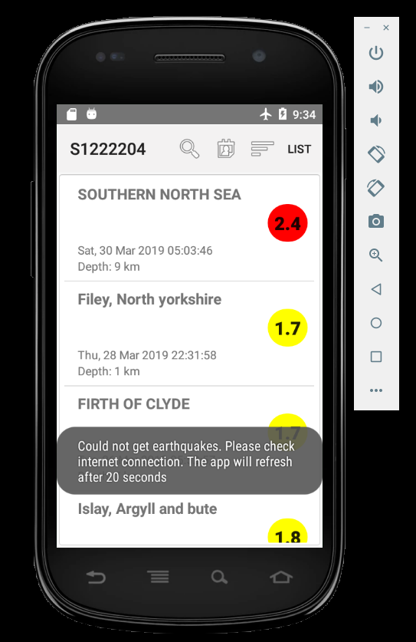

Figure 4

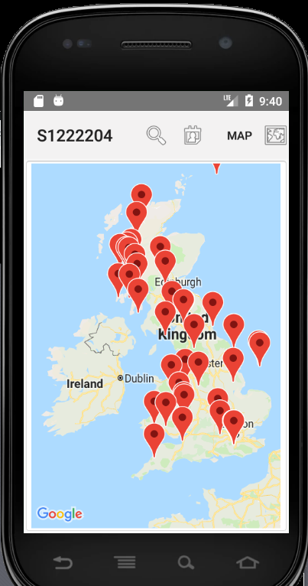

Figure 5

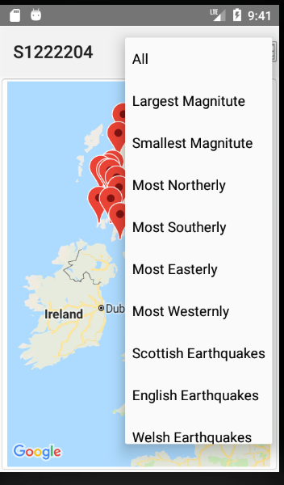

Figure 6

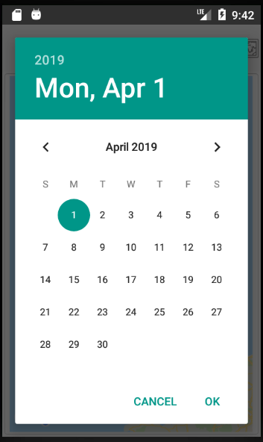

Figure 7

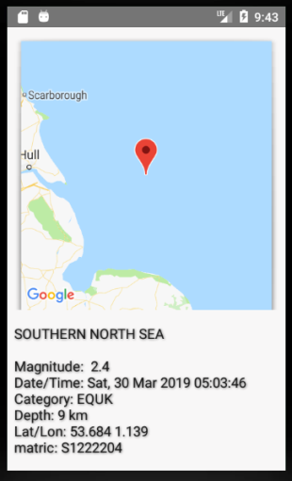

Figure 8

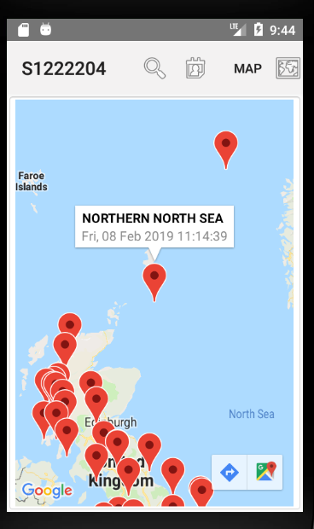

Figure 9

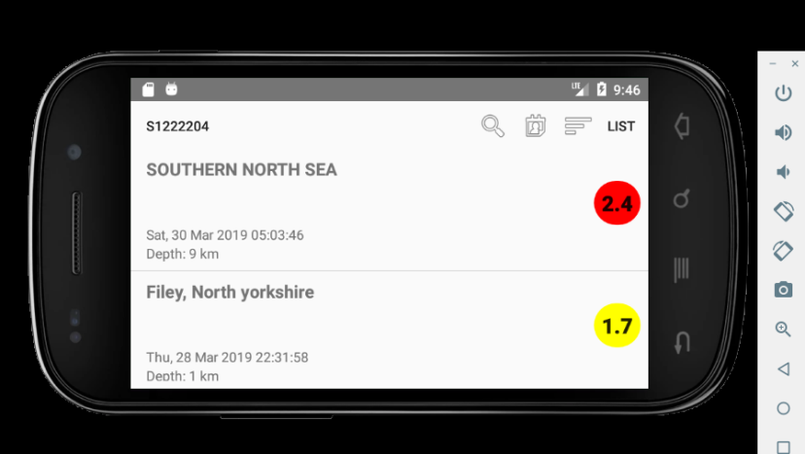

Figure 10

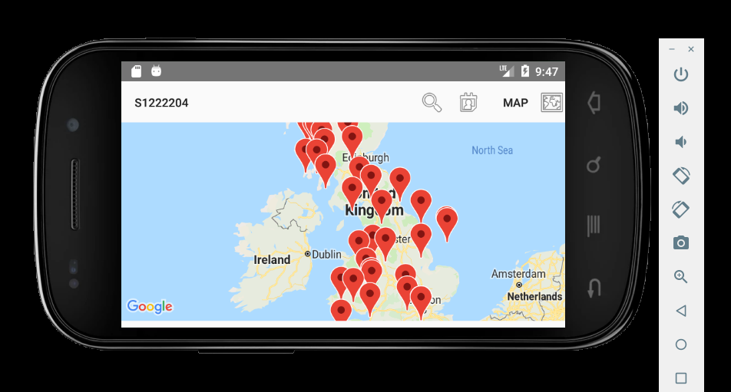

Figure 11

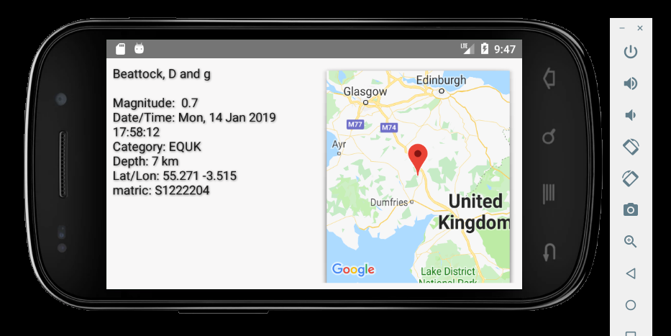

Figure 12:

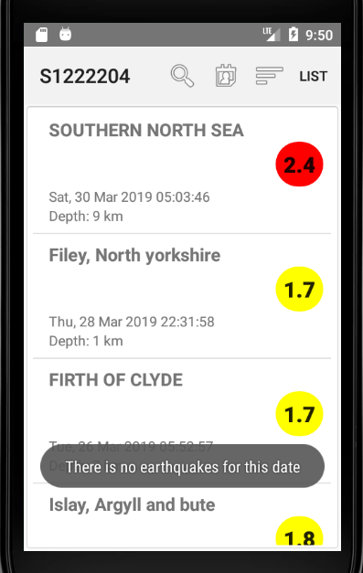

Figure 13

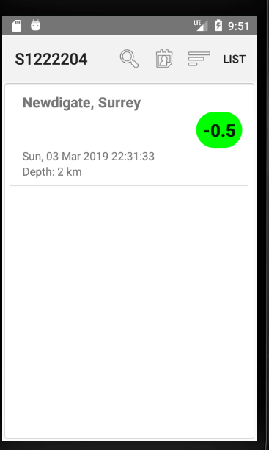

Figure 14

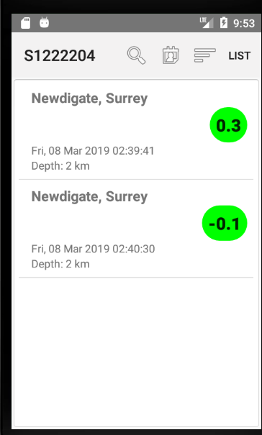

Figure 15

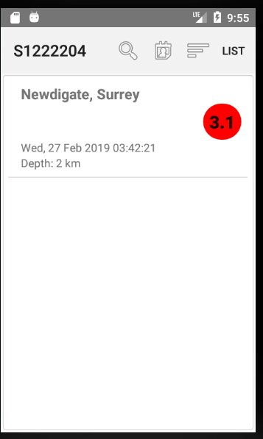

Figure 16

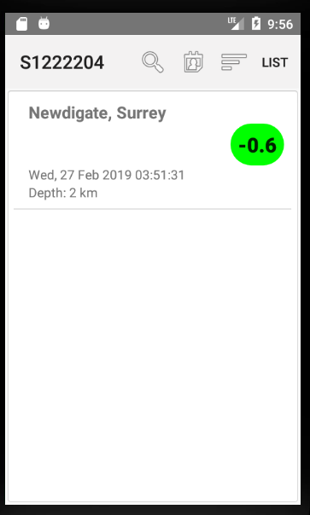

Figure 17

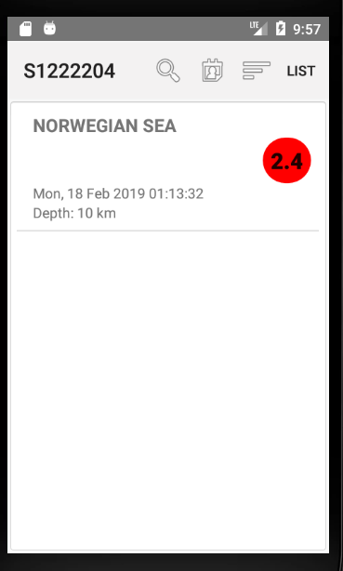 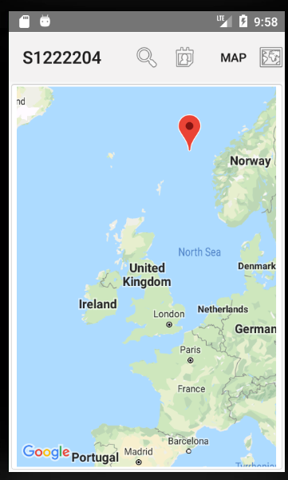

Figure 18

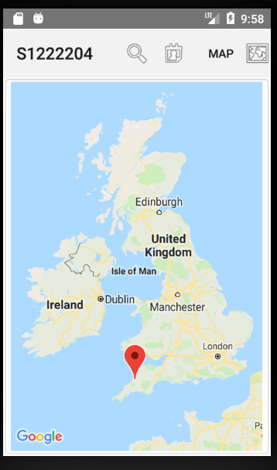

Figure 19

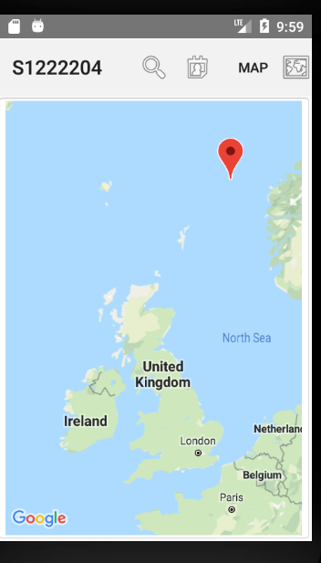

Figure 20

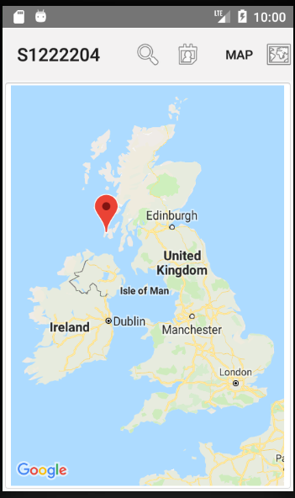

Figure 21

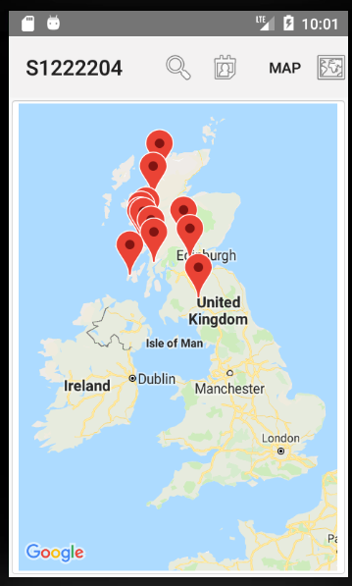

Figure 22

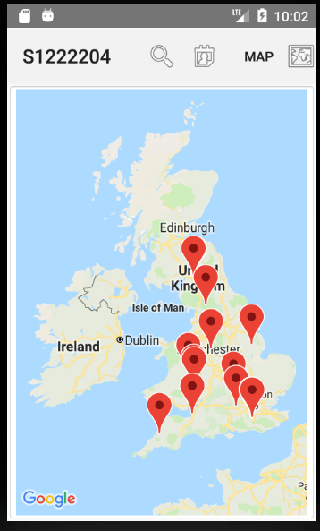

Figure 23

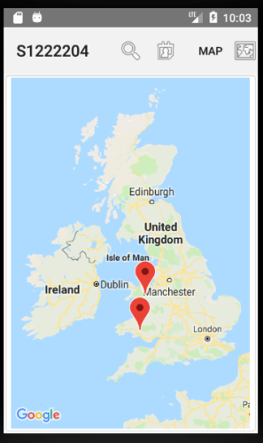

Figure 24

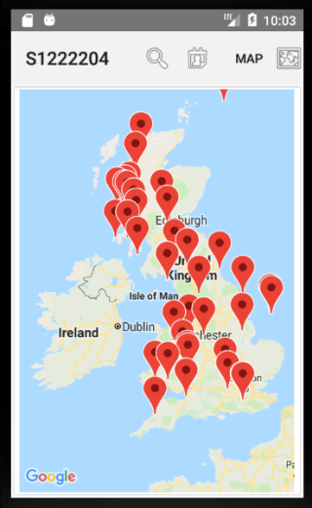

Figure 25

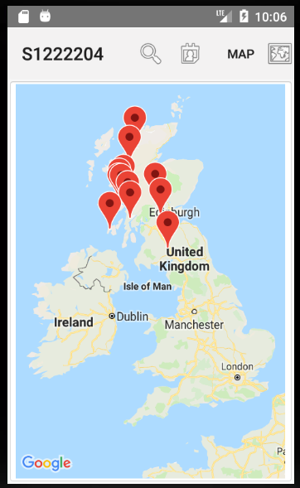 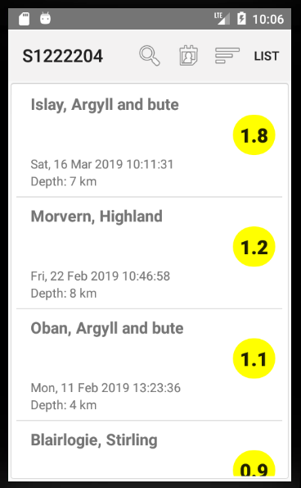

Figure 26

